

**The ultimate solution for task refinement and process improvement.**

* Align work with company objectives.
* Automate processes across all departments.
* Track progress and eliminate bottlenecks.
* Enhance and regulate work order processes.
* Automatically schedule job reminders and alerts.
* Gather performance insights and reports.

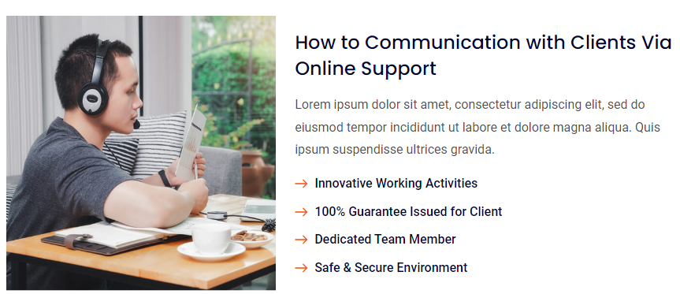

<https://templates.hibootstrap.com/vconn/default/index-2.html>

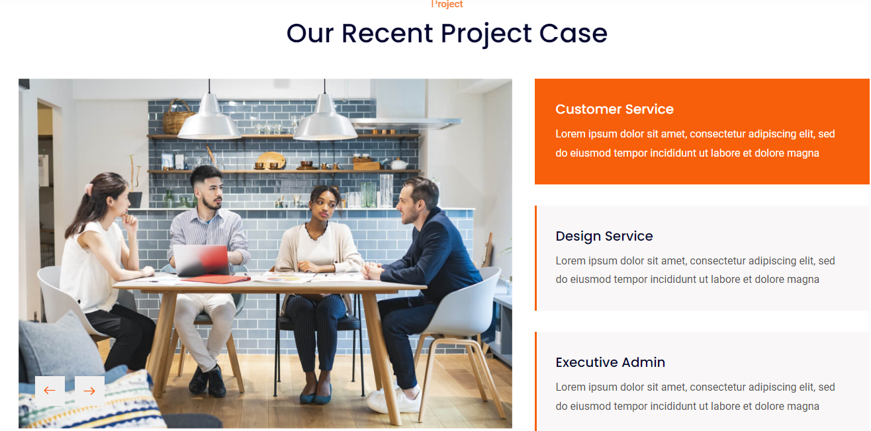

**Why Choose the I Help Desk & Ticketing System?**

AI-driven automated service management (AISM) capabilities allow for quicker, more accurate, and efficient delivery of service innovations

**One App to Meet All Your Needs**

Incoming calls, emails, and tickets can be automatically managed from a single platform.

**Enhance efficiency with full end-to-end visibility.**

Simplify priorities with clear project alignment to strategic goals, manage multiple projects efficiently, and speed up progress with enhanced stakeholder visibility.

**Monitor real-time progress and insights,**

gain an overview of multiple projects, and adjust for dependencies or scope changes instantly. Save time with AI-driven updates and reports.

**Key Features of the I Help Task Management System**

**Plan,**

organize, and collaborate on any company objective using customizable task management tools tailored to meet diverse needs at every level.

**Docs:**

Outline business cases, define project scope, and document requirements to ensure everyone has the necessary information to keep work progressing smoothly.

**Relationships:**

Connect tasks, documents, integrations, and more to access related resources and tasks in a centralized location.

**In-Depth Report Generation**:

Effortlessly generate reports on ticket progress, team performance, and issues using the reporting feature.

**More focused on accountability:**

Monitor changes to ensure transparency and accountability.

**Team Management & Assignment**:

Save time and skip meetings with digital job scheduling, ensuring each job includes all the necessary information.

[**https://templates.hibootstrap.com/vconn/default/index-3.html**](https://templates.hibootstrap.com/vconn/default/index-3.html)

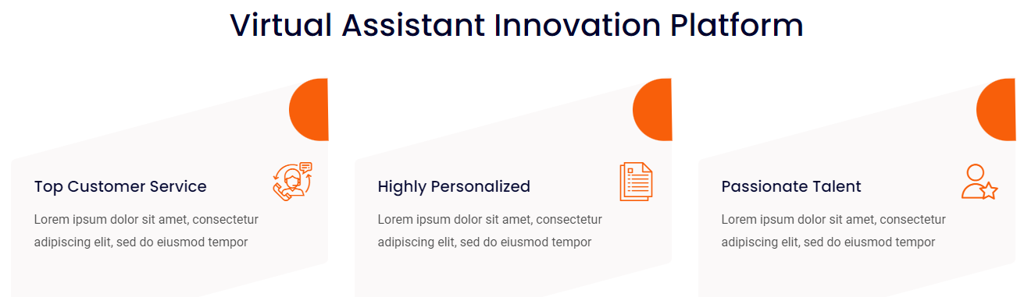

**An Overview of WHY WE NEED ITASK**

**CRM Benefits:**

* Adjusting Timeliness
* Breaking down project
* Track dependencies
* Archiving complete task
* Seeing history across all changes
* Custom filters
* Manage team
* Auto-scheduling
* Auto Notification
* Easily get access to your customers’ history and job records.
* Client relationship maintaining via Emai SMS notification
* Lead Management

